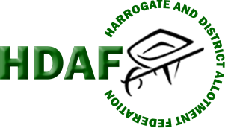
HARROGATE & DISTRICT ALLOTMENT
63
FEDERATION
65

2026 INTER-SITE COMPETITION
Our theme for 2026 is Fire and Ice
Each allotment site is challenged to produce an arrangement on this theme to include fruit, vegetables and flowers. You can use as many or as few varieties as you wish.
Your arrangement must fit in a 2ft x 2ft square and must be partially configured before arriving at the show.
The arrangements will be displayed at the Allotment Show on Sunday 16th August 2026 and will be judged as part of the Show.
There will be a trophy for the winning site.

